Exhibit A
This partial right thumbprint was found on the handle of the silverware cabinet.
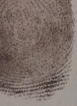
Compare it to the samples in each of the suspect profiles, to identify who left it.

Exhibit B
Some small traces of organic matter were found on the ground in the victim’s bedroom and believed to be from the intruder’s boots.
This is an image of what this looks like under the microscope.
Using the microscope slides, find out what the trace that was left at the scene is.
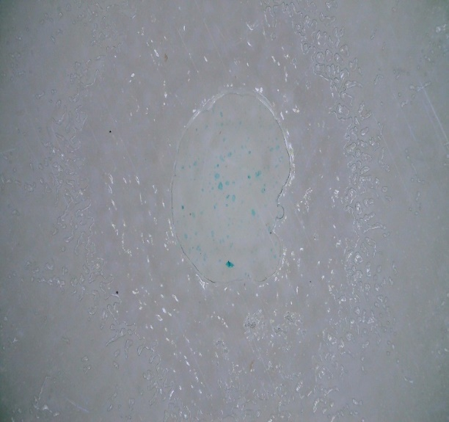

Exhibit C
Trace amounts of an unknown white powder were found on the floor in the doorway between the dining room and kitchen.
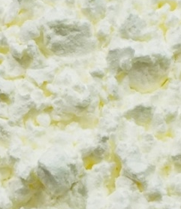
Compare the reactions of the four example white powders and find the one that matches the sample from the crime scene.

- Put 2 scoops of each powder into a beaker.
- Test the reactions by adding two drops of water, vinegar and iodine solution to the powder samples.
- Record the reactions in the table below.
- Find the sample that reacts in the same way as the powder found at the crime scene.

 | Water | Vinegar | Iodine
Baking Soda
Salt
Corn Starch
Sugar

Exhibit D

PC Long spoke to one of his confidential informants, a woman known only as Miss Terry.
She has sent him some information on each of the suspects, but it is all written in the form of riddles. Can you decode her clues about the gardens of each of the four suspects?

Henry Cartwright:
Remmu sehtni srewol fnus swor geh.
George Wilding:
8 5 / 7 18 15 23 19 / 12 5 5 11 19 /
1 14 4 / 16 15 20 1 20 15 5 19
William Townley:
He has often tried gardening,
But never succeeds.
So now has a garden,
That is just full of _____.
Benjamin Jameson:
He grows elements in his garden:
Calcium, Boron, Boron, Silver and Einsteinium.
Also, Oxygen, Nickle, Oxygen, Nitrogen and Sulfur.
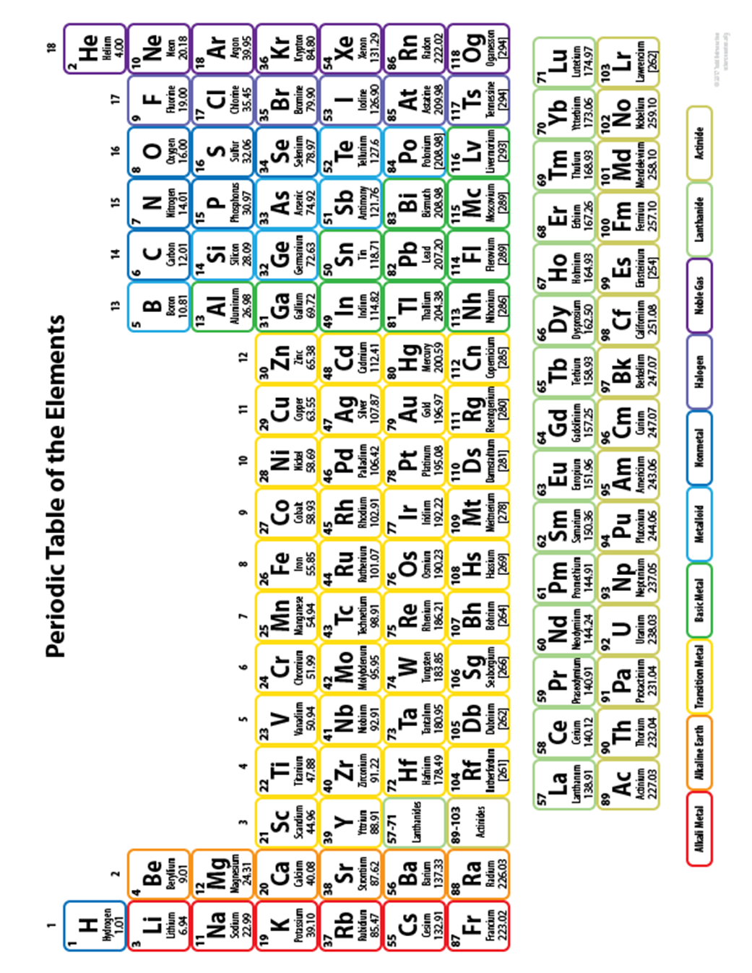
Exhibit E

An apple was found in the dining room of the victim’s house.
It had been taken from a fruit bowl on the table by the offender. He took a bite out of it and then threw it on the floor.

The bite mark clearly shows that the offender has protruding front teeth.


Using the dental x-rays in each suspect profile, try to identify who is most likely to have taken this bite.

Suspect Profile
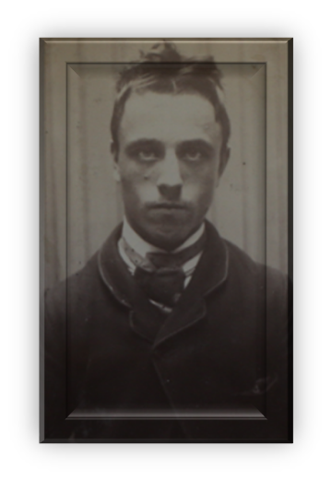 | 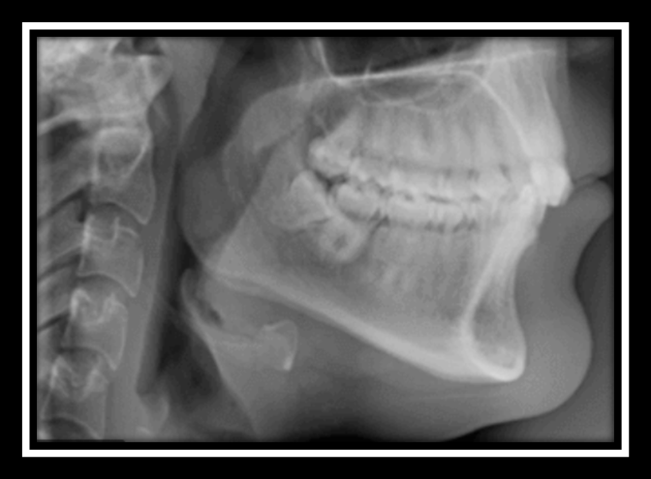
Name (Last, First) | Cartwright, Henry
Date of Birth | 14 June 1870
Address | Freeman Street
Right Thumb Print | 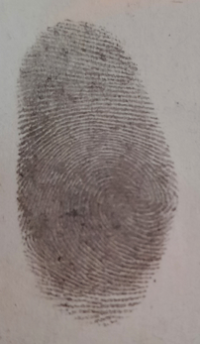
Distinguishing Features | Green Eyes,  Short, ginger hair,  3” scar on left cheek
Shoe Size | 9
Blood Type | A

Suspect Profile
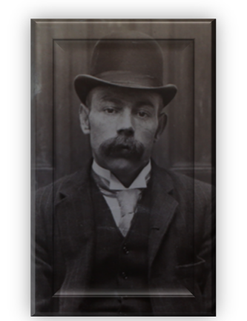 | 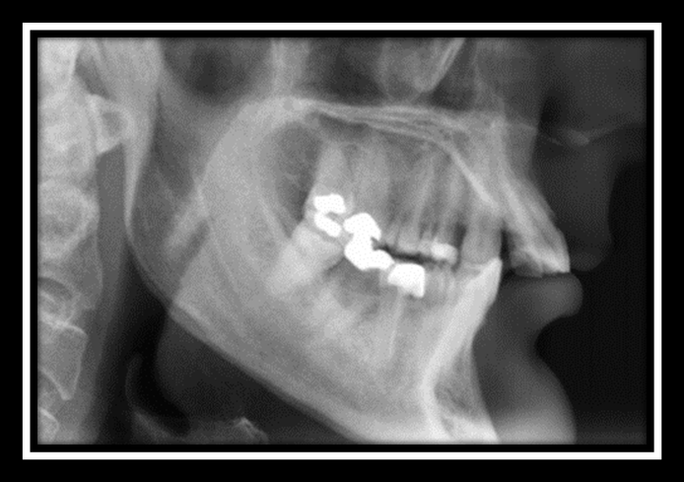
Name (Last, First) | Wilding, George
Date of Birth | 29 September 1868
Address | Dale End
Right Thumb Print | 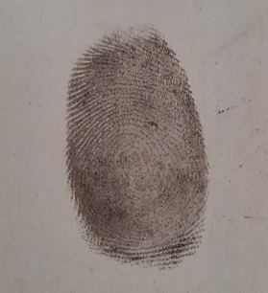
Distinguishing Features | Blue Eyes,  Dark brown hair,  Birth mark on inner right thigh
Shoe Size | 10
Blood Type | O

Suspect Profile
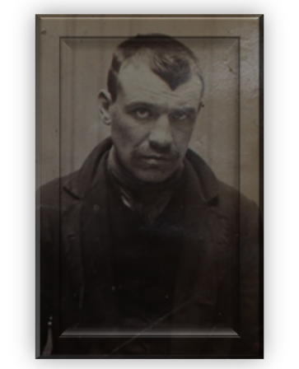 | 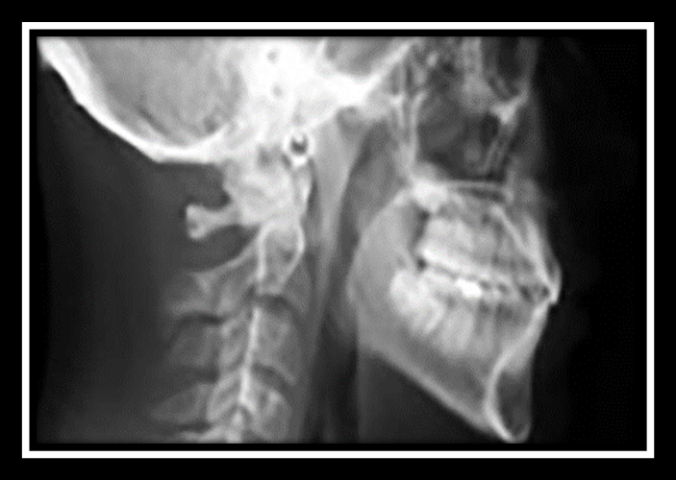
Name (Last, First) | Townley, William
Date of Birth | 27 March 1862
Address | Bell Street
Right Thumb Print | 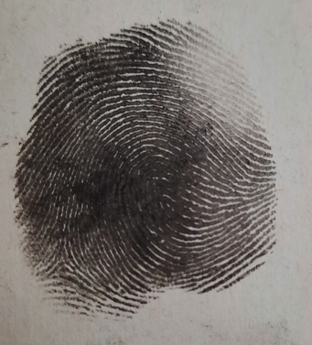
Distinguishing Features | Grey Eyes,  Brown hair,  Missing left index finger.
Shoe Size | 9
Blood Type | AB

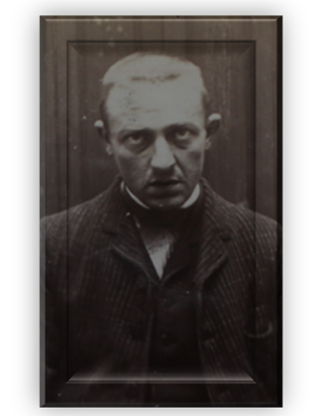 | 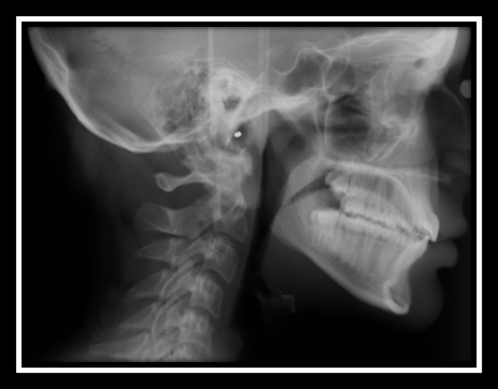
Name (Last, First) | Jameson, Benjamin
Date of Birth | 12 July 1856
Address | Blucher Street
Right Thumb Print | 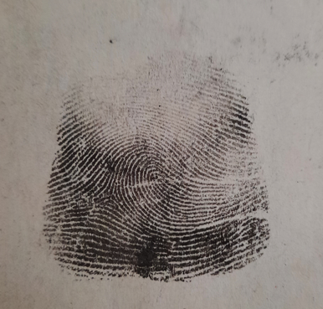
Distinguishing Features | Blue Eyes,  Blond brown hair,  Surgical scar on abdomen.
Shoe Size | 10
Blood Type | B
Suspect Profile

